Pie Charts- Questions

Key Stage 2: 2003 Paper A
1.
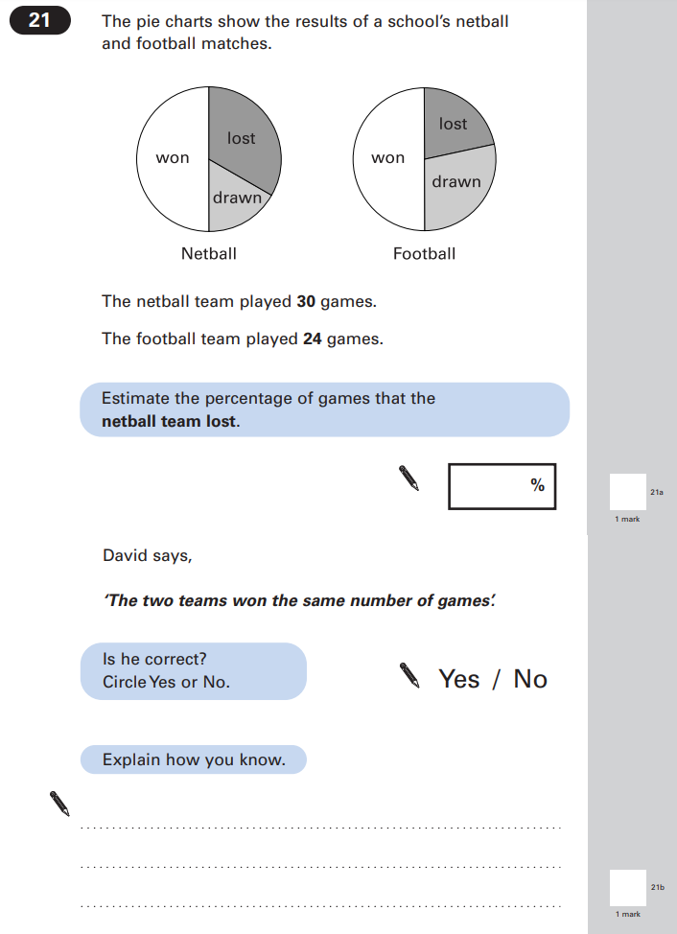

Key Stage 2: 2005 Paper A
1.
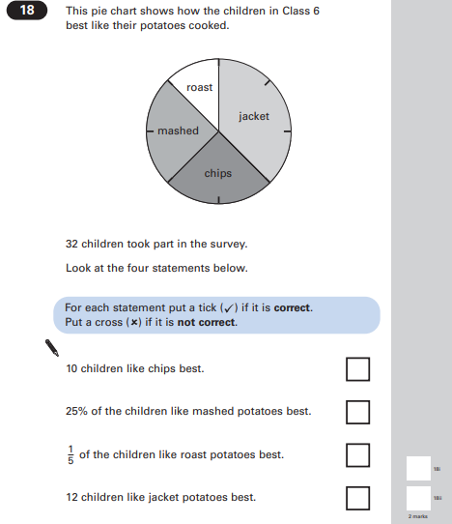

Key Stage 2: 2006 Paper A
1.
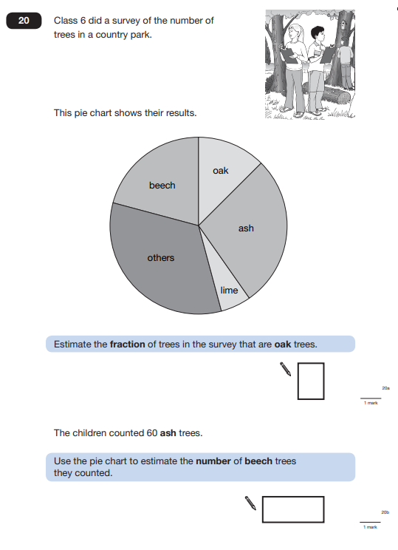

Key Stage 2: 2009 Paper A
1.
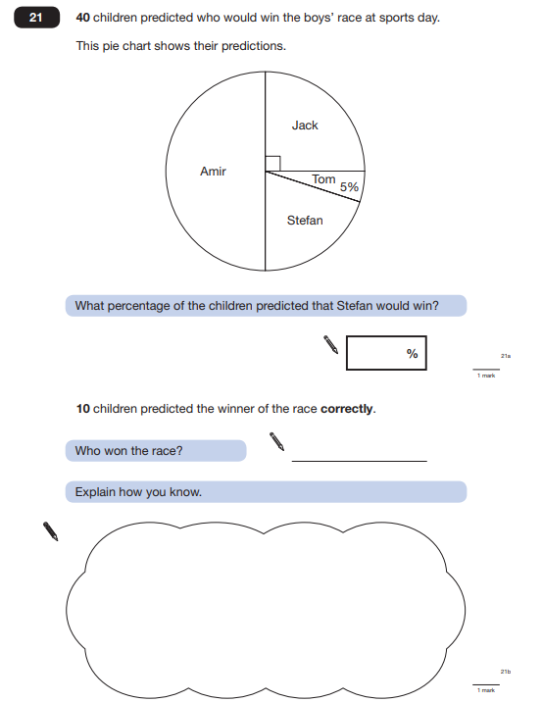

Key Stage 2: 2010 Paper A
1.
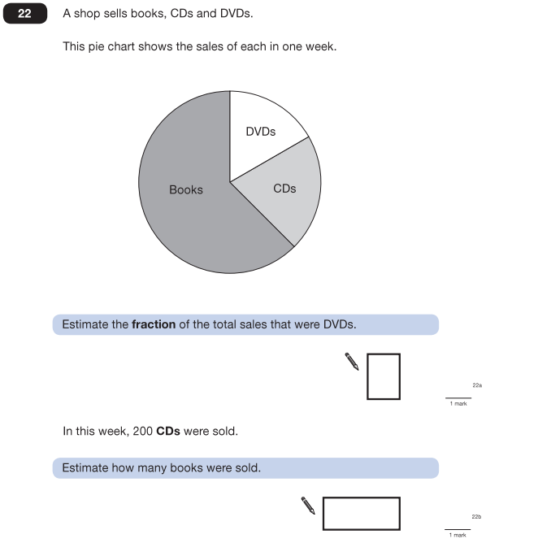

Key Stage 2: 2011 Paper B L6
1.
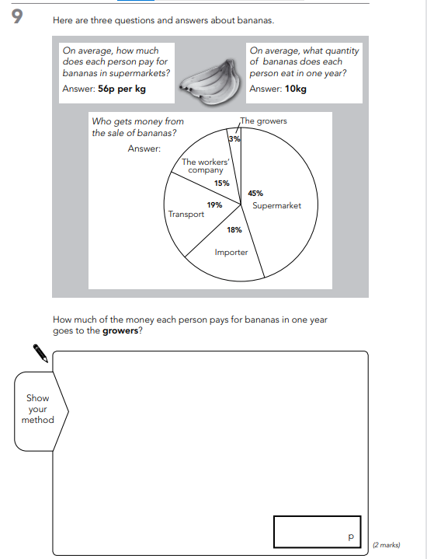

Key Stage 2: 2012 Paper A L6
1.
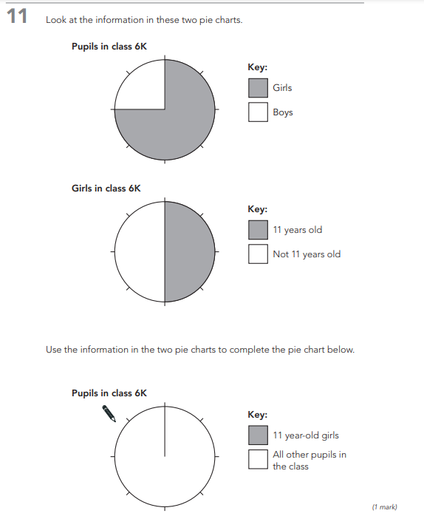

Key Stage 2: 2012 Paper A
1.
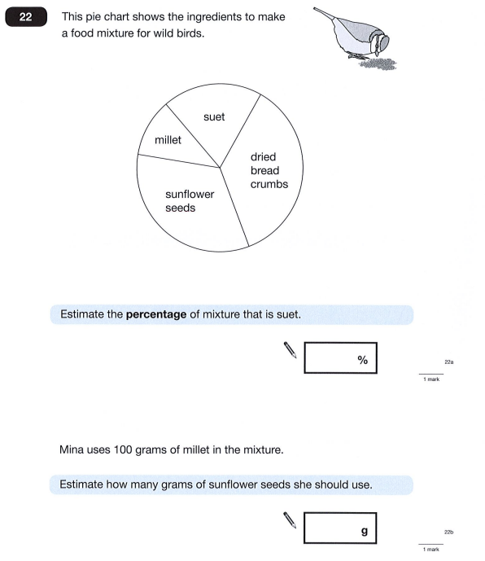

Key Stage 2: 2013 Paper B
1.
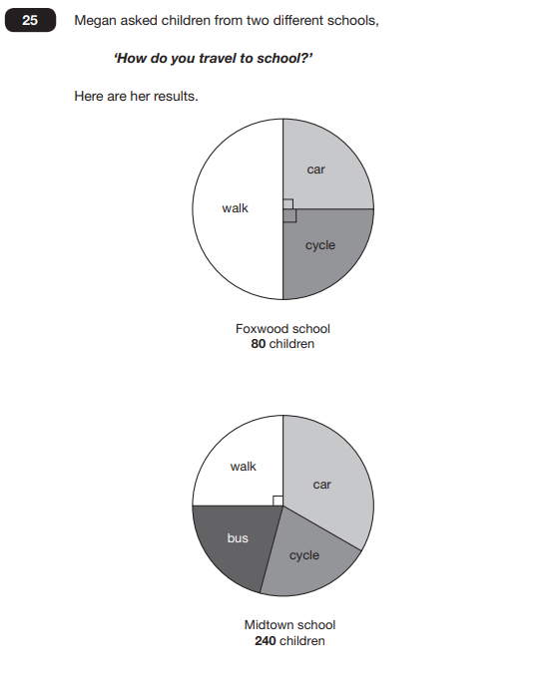

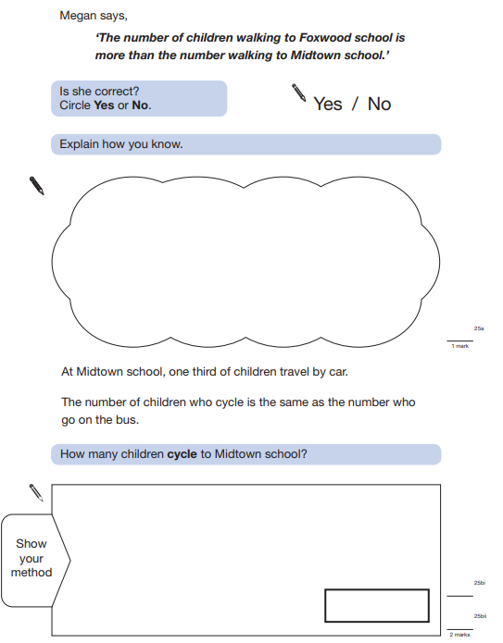

Key Stage 2: 2014 Paper A L6
1.
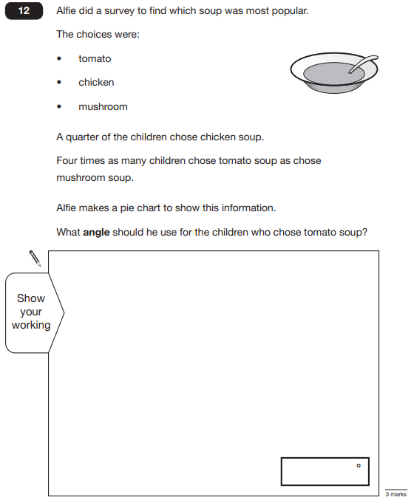

Key Stage 2: 2014 Paper B L6
1.
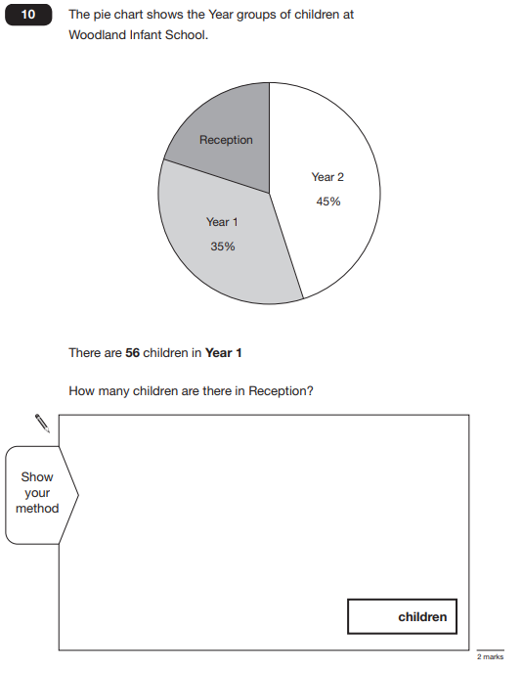

Key Stage 2: 2015 Paper A L6
1.
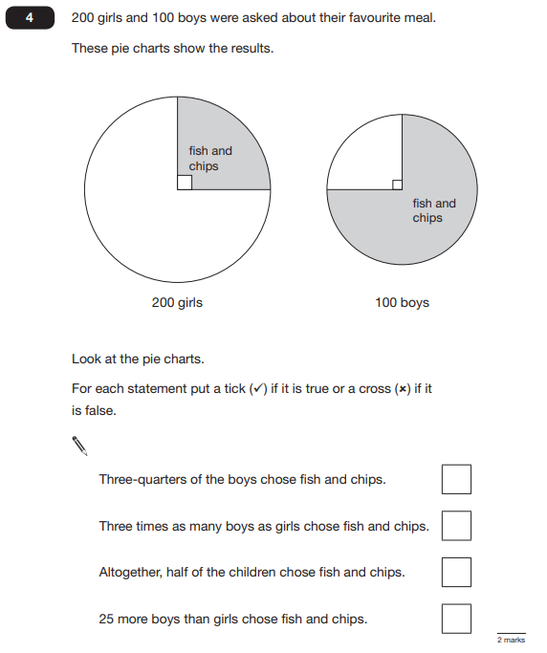

Key Stage 2: Paper 2 and 3 Reasoning - Sample
1.
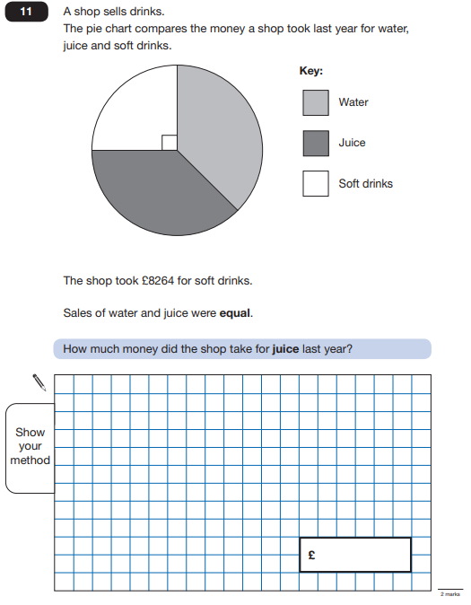

Key Stage 2: 2016 Paper 2 Reasoning - Sample
1.
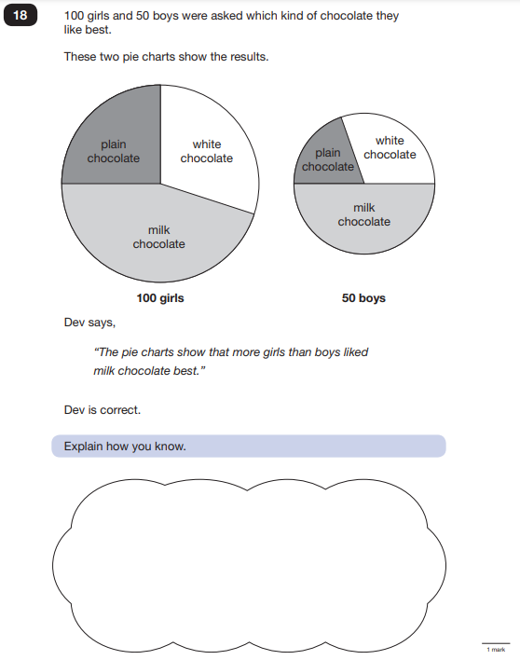

Key Stage 2: 2018 Paper 3 Reasoning
1.
